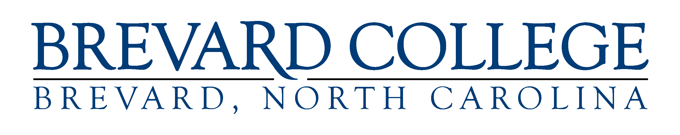

Student Achievement Data Reporting

Completion and Retention Rates
Metric | 2018-2019 | 2017-2018 | 2016-2017
Completion Rate | 33.5% | 32.1% | 45.8%
First-Year Retention Rate | 68% | 57% | 54%

Course Success Rates
Term | Enrollment Headcount across all courses (opportunities for a student to earn a grade) | A, B, C Grade Count across all courses | Average Course Success Rate
SP 2017 | 2544 | 2056 | 81%
FA 2017 | 2,668 | 2180 | 82%
SP 2018 | 2,343 | 1938 | 83%
FA 2018 | 3014 | 2500 | 83%
SP 2019 | 2448 | 2078 | 85%
FA 2019 | 3322 | 2789 | 84%

